AASHTO Innovation Initiative
[Proposed] Nomination of Innovation Ready for Implementation

Sponsor

Nominations must be submitted by an AASHTO member DOT willing to help promote the innovation. If selected, the sponsoring DOT will be asked to promote the innovation to other states by participating on a Lead States Team supported by the AASHTO Innovation Initiative.
1. Sponsoring DOT (State): California DOT
2. Name and Title: Louie La Compte, Field Systems Engineer
Organization: California Department of Transportation
Street Address: 7183 Opportunity Road
City: San Diego
State: CA
Zip Code: 92111
Email: louie.lacompte@dot.ca.gov
Phone: (858) 518-3850
Fax: (858) 637-7128

Innovation Description (10 points)

The term “innovation” may include processes, products, techniques, procedures, and practices.
3. Name of the innovation:
Connected Vehicle Technology deployment on Route 15
4. Please describe the innovation.
Deployed a vehicle to infrastructure (VTI) system which is the State's data infrastructure portion of the connected vehicle technology on 20 miles of Route 15. Since the autonomous vehicle proving grounds is within the project limits, in the near future, the vehicle to infrastructure system will provide real time traffic and environmental data into the autonomous and connected vehicle's infotainment screen.
5. What is the existing baseline practice that the innovation intends to replace/improve?
Existing technology uses changeable message signs, static roadway signs, and traffic signal systems to communicate traffic and environmental information to the traveling public. The information delivered to the traveling public are limited.
6. What problems associated with the baseline practice does the innovation propose to solve?
The vehicle to infrastructure system laid the groundwork for future development in the connected and autonomous vehicle State's infrastructure. At maturity, the system will replace 7 of 9 existing ITS elements, reduce maintenance resources, improve the efficiency and safety to the traveling public. The vehicle to infrastructure system aims to improve efficiency of the vehicle and to realize zero fatality from vehicular accidents.
7. Briefly describe the history of its development.
On 2013, SB 743 was approved and incorporated in the State's CEQA guidelines in 2018 to reduce vehicle miles traveled. Caltrans' 2020 Strategic Highway Safety Plan envisions zero fatalities on the State Highway system by 2050. The Vehicle to Infrastructure system is an attempt to both meet SB 743, Caltrans' Strategic Highway Safety Plan, address climate change through travel efficiency, reduce fix objects on the freeway by reducing ITS elements and reduce man-hours to maintain vital ITS elements.
8. What resources—such as technical specifications, training materials, and user guides—have you developed to assist with the deployment effort? If appropriate, please attach or provide weblinks to reports, videos, photographs, diagrams, or other images illustrating the appearance or functionality of the innovation (if electronic, please provide a separate file). Please list your attachments or weblinks here.
Developed specifications, construction detail plans, estimates, systems engineering, maintenance procedures, operation plan, and selected a handful application to demonstrate the Vehicle to Infrastructure System integration and applicability. Conducted on-site demonstration and online presentation illustrating the benefits of the system and to begin the integration now rather than later.
Attach photographs, diagrams, or other images here. If images are of larger resolution size, please provide as separate files.
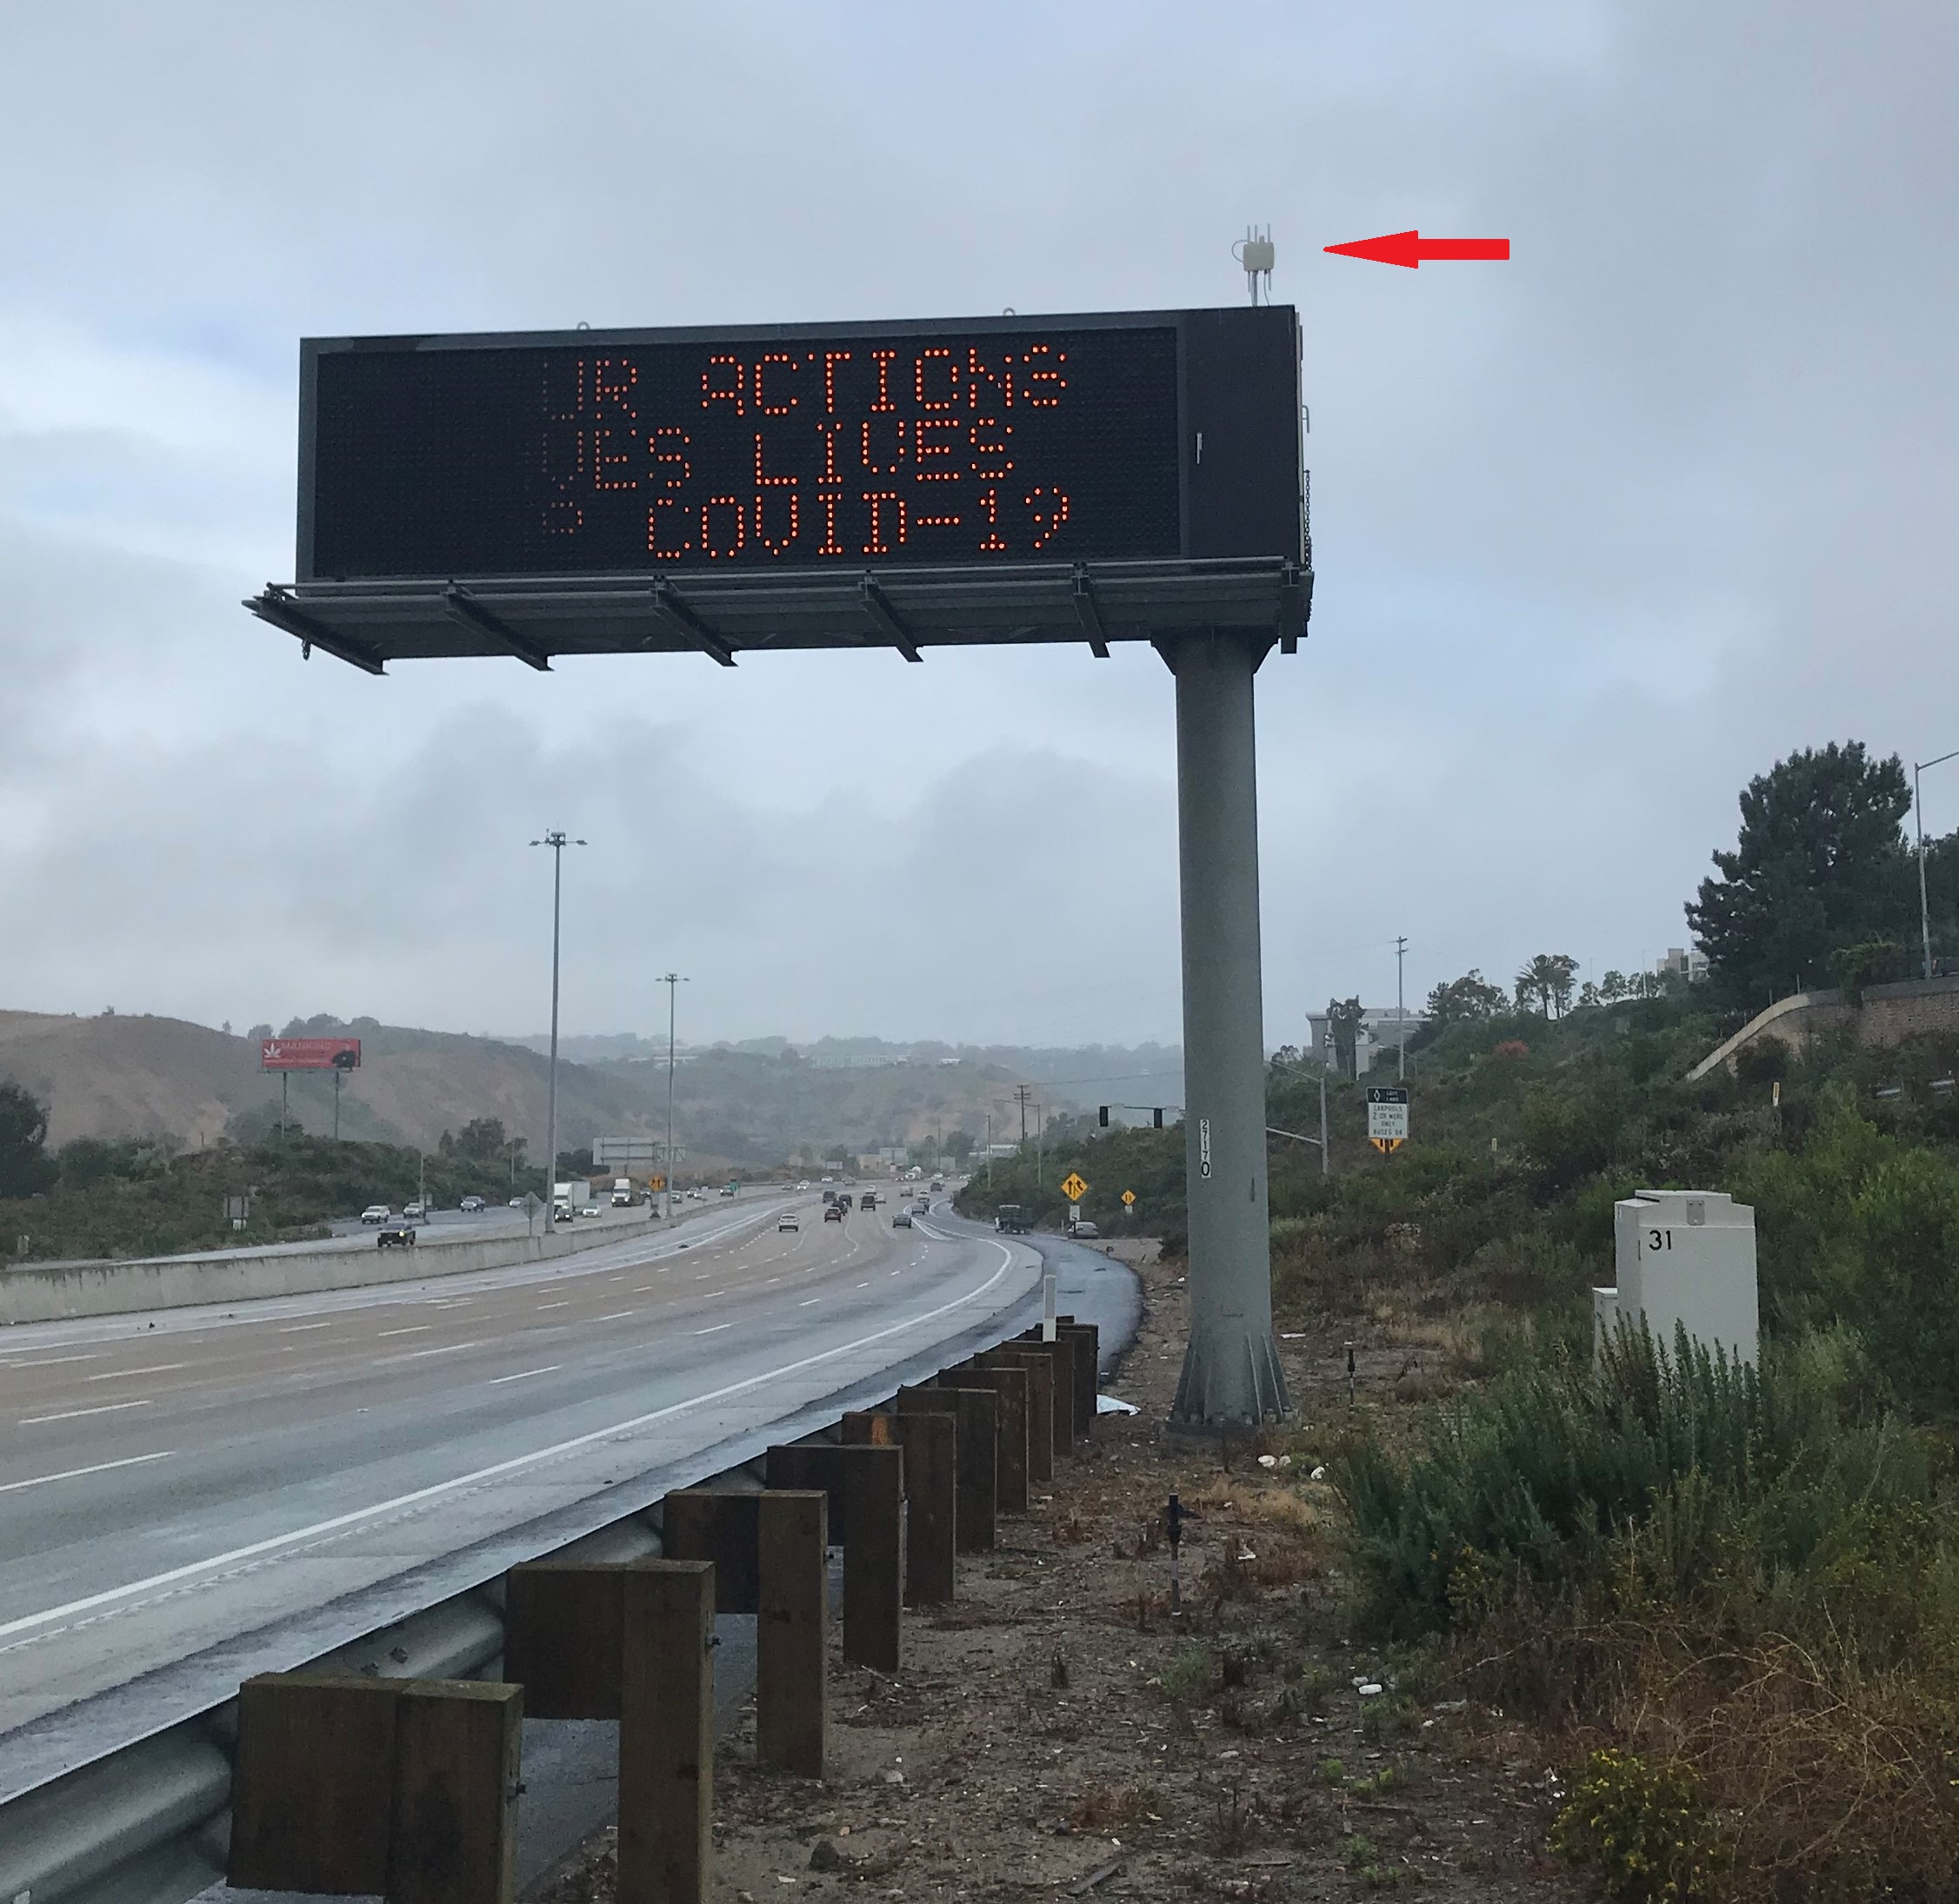 | 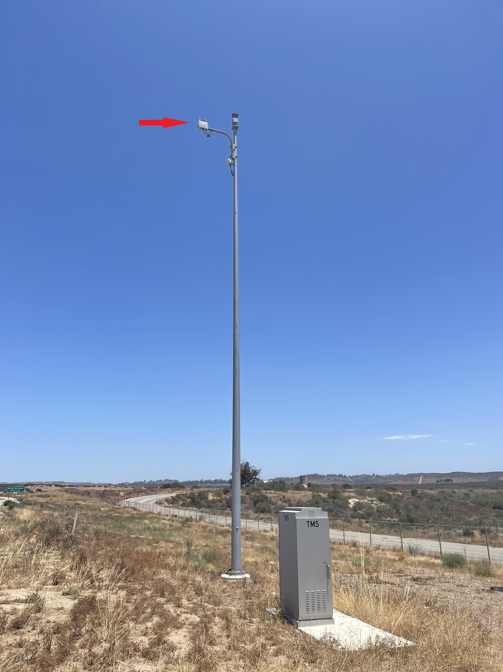 | 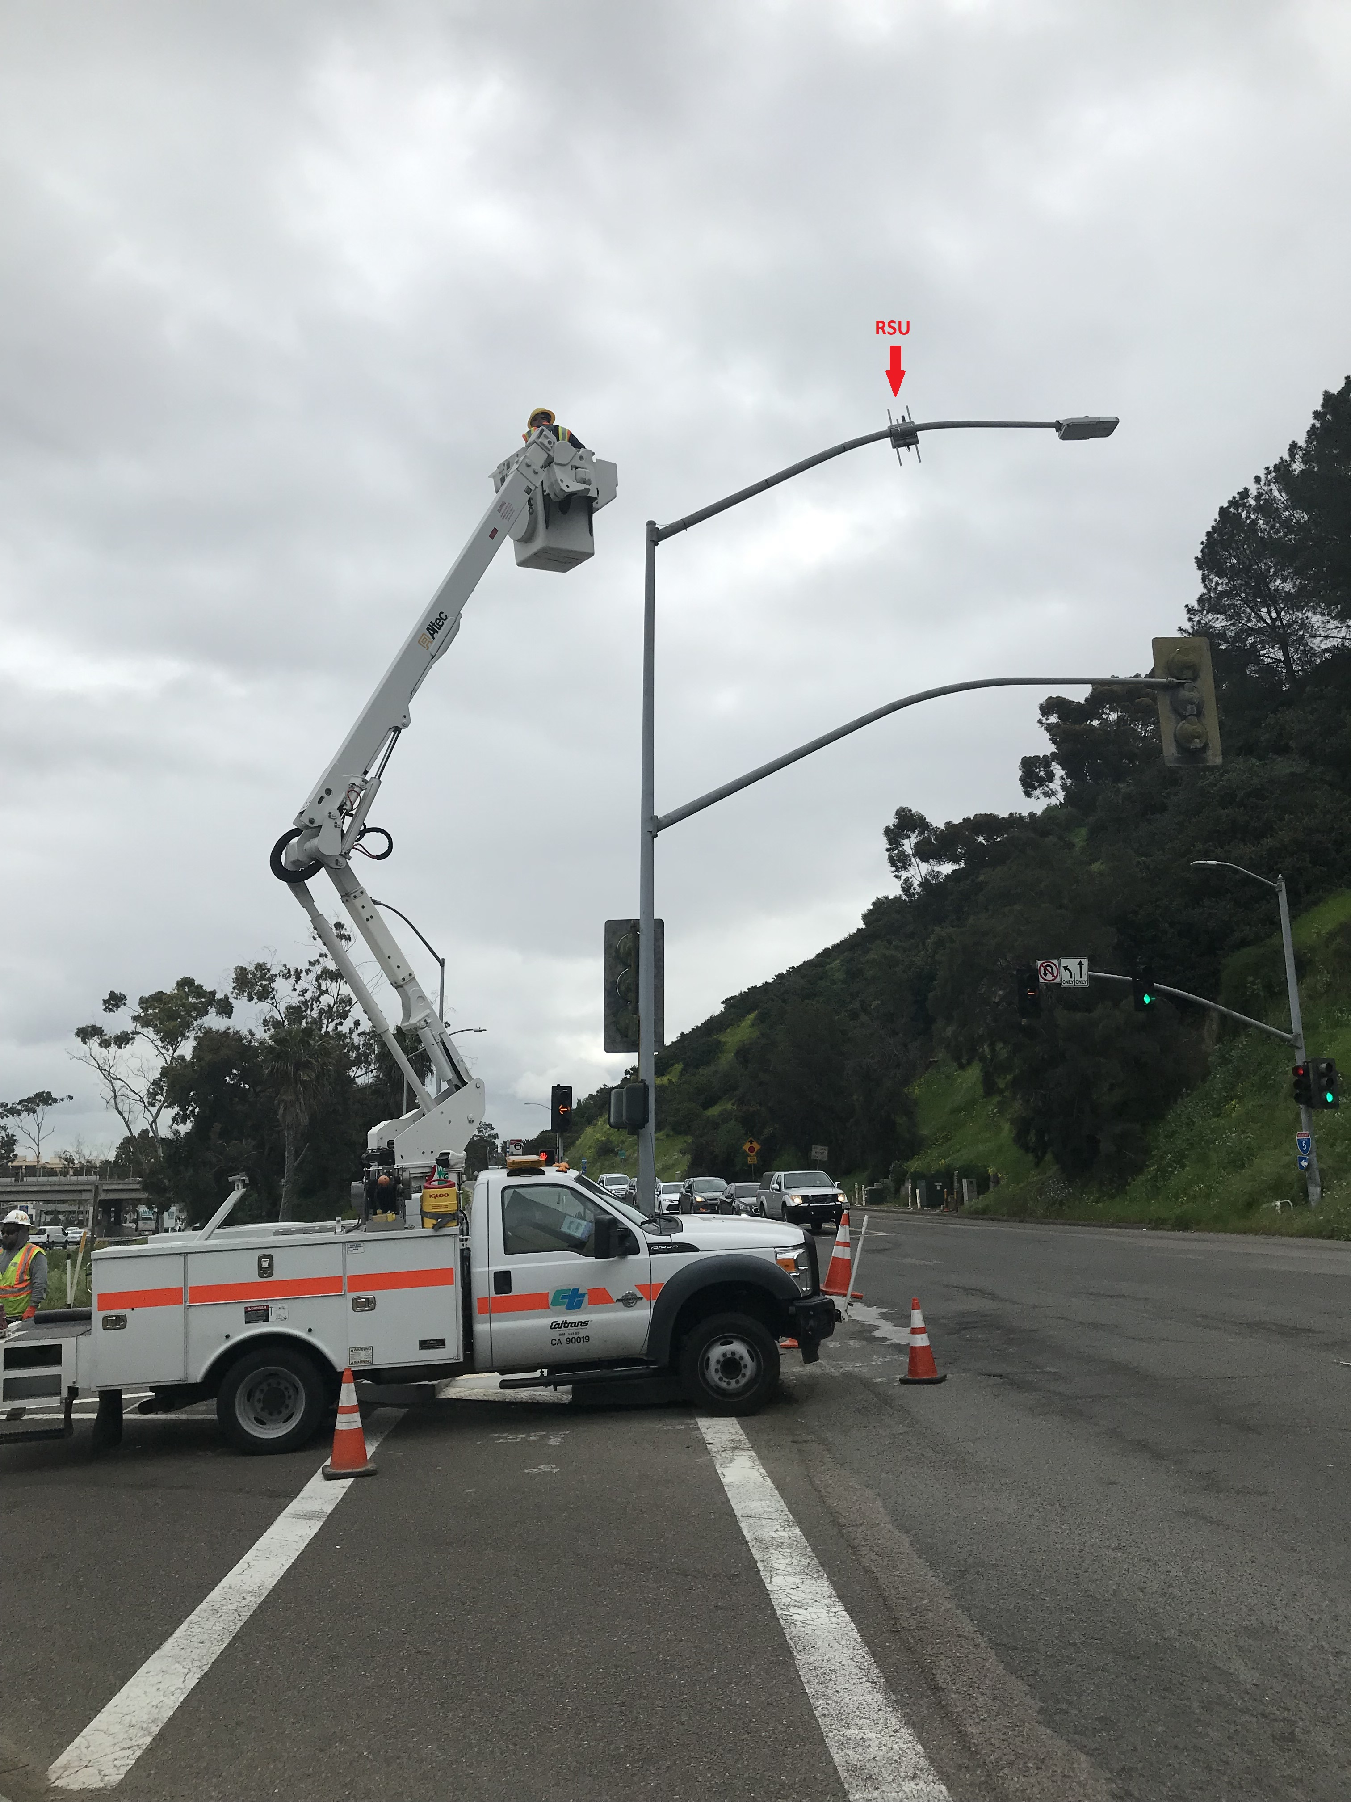
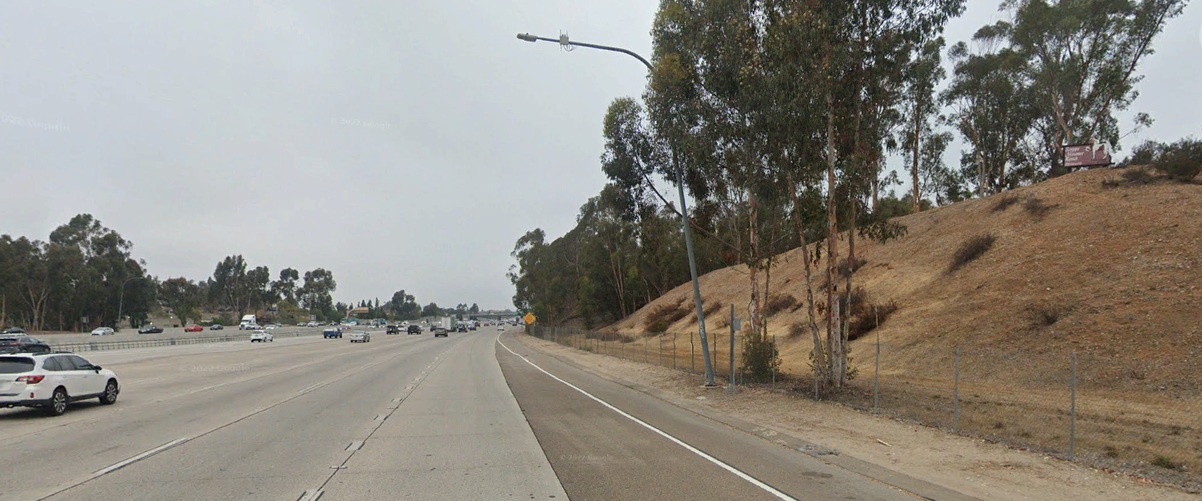 | 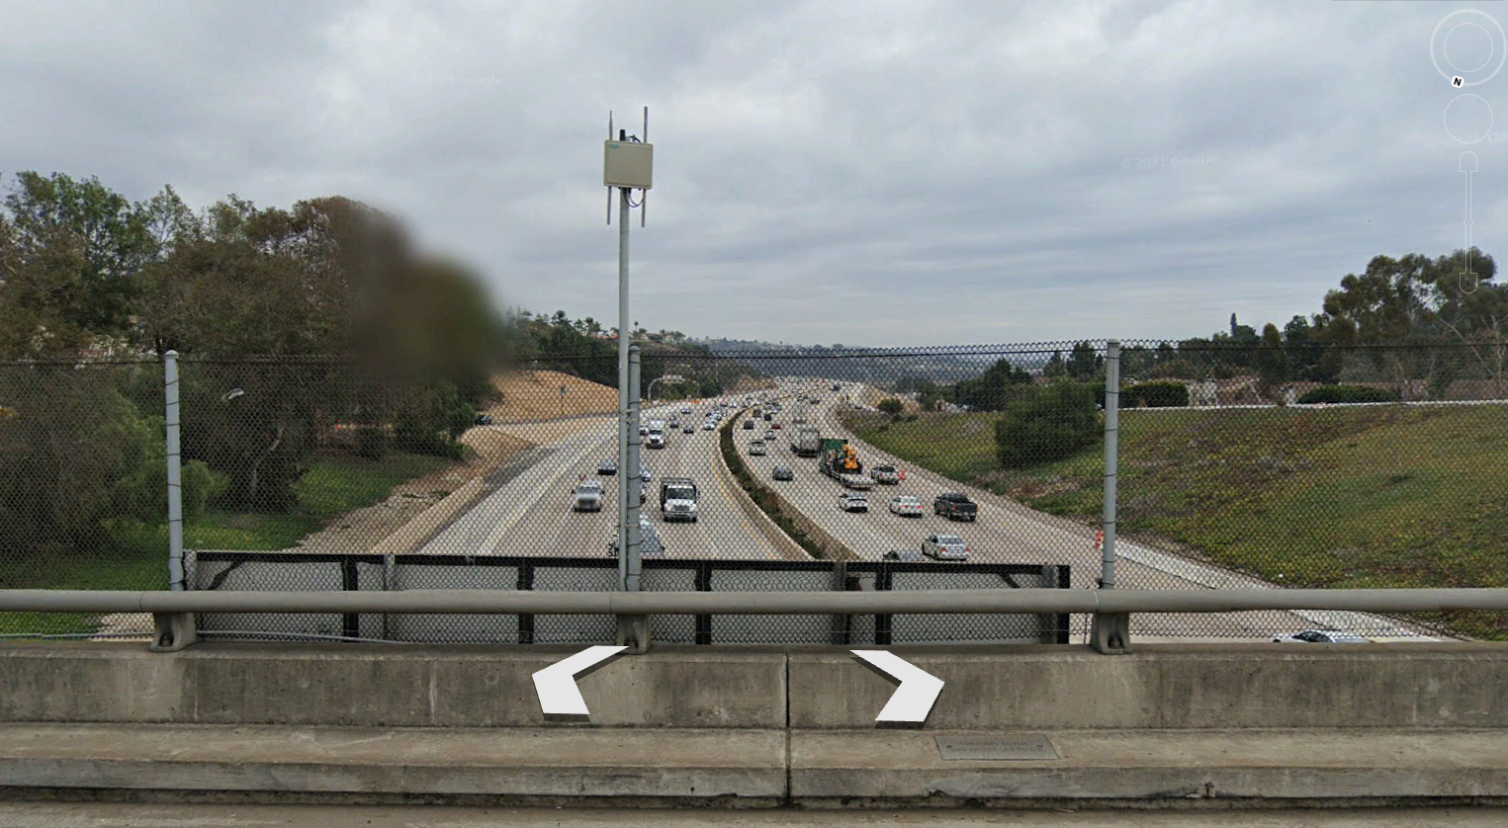 | 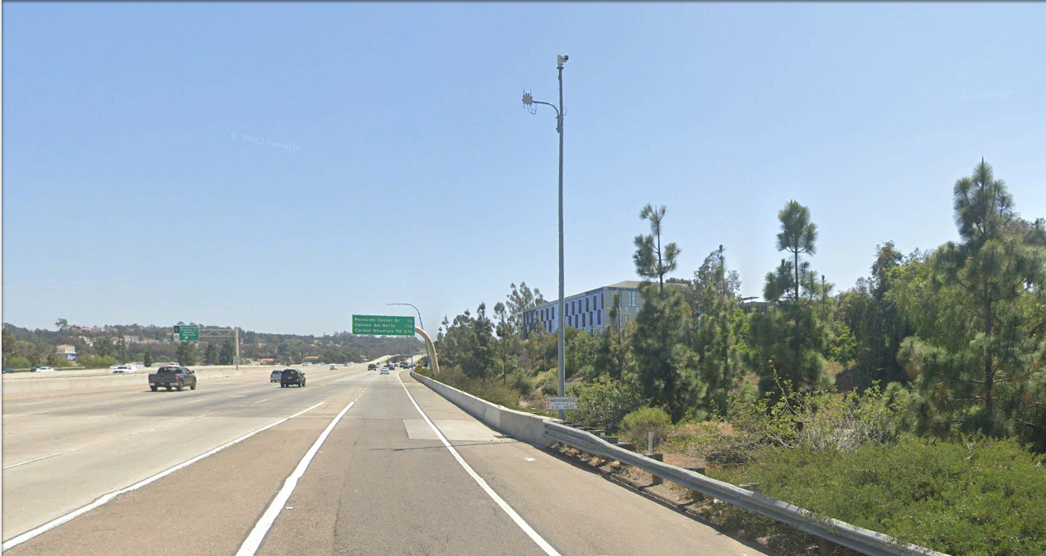


State of Development (40 points)

Innovations must be successfully deployed in at least one State DOT. The AII selection process will favor innovations that have advanced beyond the research stage, at least to the pilot deployment stage, and preferably into routine use.
9. How ready is this innovation for implementation in an operational environment? Please select from the following options. Please describe.
☐ Prototype is fully functional and yet to be piloted
☐ Prototype has been piloted successfully in an operational environment
☒ Technology has been deployed multiple times in an operational environment
☒ Technology is ready for full-scale implementation
The technology is fully matured and ready for mass deployment. There are some technical adjustments necessary due FCC ruling but are negligible parts replacement. The components of the system for the roadway's data infrastructure can be deployed now. Car manufacturer should begin installing the onboard unit soon after the FCC ruling is made official.
10. What additional development is necessary to enable implementation of the innovation for routine use?
Automotive manufacturers must install the onboard unit in the vehicles today to effectively utilize the full benefit of the connected vehicle technology in the near future.
11. Are other organizations using, currently developing, or have they shown interest in this innovation or of similar technology?? ☒ Yes ☐ No
If so, please list organization names and contacts. Please identify the source of this information.
Organization | Name | Phone | Email
Florida DOT | Click or tap here to enter text. | Click or tap here to enter text. | Click or tap here to enter text.
New York DOT | Click or tap here to enter text. | Click or tap here to enter text. | Click or tap here to enter text.
Wyoming DOT | Click or tap here to enter text. | Click or tap here to enter text. | Click or tap here to enter text.

Potential Payoff (30 points)

Payoff is defined as the combination of broad applicability and significant benefit or advantage over baseline practice.
12. How does the innovation meet customer or stakeholder needs in your State DOT or other organizations that have used it?
Division of Maintenance appreciated the simplicity of the technology, reduction of maintenance man-hours and the truncating from 9 to 2 TMS elements as a major benefit in the future. Transportation Management Center sees the data rich environment for traffic analysis and foresee zero fatalities due to vehicle accidents as more plausible than ever.
13. Identify the top three benefit types your DOT has realized from using this innovation. Describe the type and scale of benefits of using this innovation over baseline practice. Provide additional information, if available, using quantitative metrics, to describe the benefits.
Benefit Types | Please describe:
Improved Safety | Situation awareness between vehicles and with advance traffic and environmental condition from the Traffic Management Center will bring zero fatality due to vehicular accidents closer to reality. The reduction of TMS elements due to the consolidation to a single unit means a reduction in fixed objects on the freeways resulting in fewer obstacles that a vehicle can hit.
Environmental Benefits | Improving traffic congestion and travel efficiency reduce the carbon footprint from combustion engines. Reduce fuel consumption.
Cost Savings | With the reduction of TMS elements in the freeway due to consolidating to a single unit would be a cost saving for both lifecycle replacement and man-hours for troubleshooting of just 1 unit instead of 7 units

Provide any additional description, if necessary:
Click or tap here to enter text.
14 How broadly might this innovation be deployed for other applications. in the transportation industry (including other disciplines of a DOT, other transportation modes, and private industry)?
Connected Vehicle Technology is mostly for the transportation industry which include freight, trains, mass transportation and other micromobility devices. Connect Vehicle Technology may be use at intersection for pedestrian safety.

Market Readiness (20 points)

The AII selection process will favor innovations that can be adopted with a reasonable amount of effort and cost, commensurate with the payoff potential.
15. What specific actions would another organization need to take along each of the following dimensions to adopt this innovation?
Check boxes that apply | Dimensions | Please describe:
☒ | Gaining executive leadership support | The various DOT must realize the advancements in technology has provided a means to reduce fatalities, improve vehicle efficiency and reduce operation-and-maintenance cost
☒ | Communicating benefits | the proper deployment of the technology is very important to yield the most benefits thus various segments of the DOT must understand the limitation as well
☐ | Overcoming funding constraints | Click or tap here to enter text.
☐ | Acquiring in-house capabilities | Click or tap here to enter text.
☐ | Addressing legal issues (if applicable) (e.g., liability and intellectual property) | Click or tap here to enter text.
☒ | Resolving conflicts with existing national/state regulations and standards | Federal and State laws must coincide to standardize data transmitted from vehicles and from the infrastructure. Mandate all vehicles to install the necessary equipment to communicate with State-owned Vehicle to Infrastructure System and other connected vehicles
☐ | Other challenges | Click or tap here to enter text.

16. Please provide details of cost, effort, and length of time expended to deploy the innovation in your organization.
Cost: $11k per installation when an existing pole is available
Level of Effort: minimal effort when an existing post can be used, medium effort when a new pole is necessary
Time: 2 to 3 days per site when an existing post is used, 8 working days when a new pole is installed.
17. To what extent might implementation of this innovation require the involvement of third parties, including vendors, contractors, and consultants? If so, please describe. List the type of expertise required for implementation.
A licensed electrician (C-10) to install the power and communication to the various system's components. The manufacturer must be present during commissioning and provide training to the operators and maintenance personnel.

